Impacts of Climate Change in the Contaminants Pathways and their Health Impacts in Canada

Georgia Georgiou

2012
Table of Contents
Introduction 2
Contaminants Pathways 3
The Arctic Ocean and nearby seas 5
Foodborne Diseases 7
Seafood 7
Ocean Effects 8
Biological effects 8
Conclusions 9

Introduction

The climatic changes are a global issue that concerns the governments all over the world. It affects various aspects including agriculture, water sources availability, health, economy, biodiversity, precipitation patterns of chemical compounds and others. Some effects of climate change are already observable in some places of Earth due to the physicochemical properties of each environment, the latitude and longitudes of each country as well.
The effects of climate change have been a global concern since they began to be observable during the past decade. The atmospheric and water temperature has risen during the past 20 years [1] [2]. This increase induces changes in the hydrological cycle [3], and on the Earth’s ice [4]. Studies have been shown that the sea surface temperatures in the North and Baltic Seas are increased significantly compared to previous measurements that have taken and for instance temperatures since summer of 1985 have risen at around three times from that which were expected to happen in the 21st century [5]. Adaptation to habitats with new temperatures determines the ability of the populations to survive in such warm environments and if they will be able to increase their tolerance thermal limits in order to be able to survive. Considering all the above, and the fact that the temperature has been already increased to levels that some species cannot adapt as it should be, the biodiversity of the ecosystems is affected.
Although the global warming is of great importance, and several impacts of climate change are derived from this, there are other changes that are equally important and we need to consider. Several ecosystems have been affected from the climate change. For instance, marine ecosystems are influenced by eutrophication [6], introduction of invasive species [7], and also by acidification resulting from the humankind activities that release high amounts of CO₂ in the atmosphere [8]. For example, the frequent storms which in some cases are due to the increased temperature and the high sea level.
Arctic has been already affected by the Climate Change and this has been observed during the past decade. Several changes such as the atmospheric sea-level pressure, wind fields, sea-ice drift, ice cover, length of melt season, change in precipitation patterns, changes in hydrological cycles, in ocean currents and water mass distribution are just some of a whole bunch of altered conditions. Possibly, all these primary alterations have influenced the carbon cycle and eventually the biological communities although this is not easy to be observed. Considering that contaminants enter the global system and have as mediums of transport the air and the water, it can be obvious that the already mentioned changes will affect in some way the pathways that the contaminants follow for their dispersion.
In this study, it will be discussed in depth the way that the climatic changes affect the contaminants pathways and the extent that they cause it. The area understudy as it was selected is Canada in United States which is an area in Arctic. Additionally, the impacts of these changes in the human health will be addressed and some prevention measures will be suggested.

Contaminants Pathways
Alterations in climate such as the winds, precipitation, currents, temperature, ice and snow cover can lead to the alteration of the usual transport, deposition and fate of hazardous compounds [9]. These contaminants can pass into the sea watersheds through discharges from point sources, river run off or sewage systems, atmospheric deposition and from boats.
Salinity is a determinant factor for the Bioavailability of particular compounds such as metals [10]. Moreover, there is a plenty of studies that support that low level of salinity favors the uptake of metals from various aquatic organisms [11]. On the other hand, there are other studies which argue that solubility of several PAHs depends on salinity in the ambient water [12]. Hence, change of the dominants environmental conditions will also determine the level of exposure of marine organisms to hazardous compounds.
Additionally, it has been recognized a link between the climate change and the frequent extreme weather events. These events influence the runoff, the salinity and erosion in estuaries and coastal wetlands and the biodiversity. It has been suggested that the storms react with the chemicals when the sediment-bound toxic substances and pathogens pass back into the coastline environments after the occurrence of rainstorms [13]. On the other hand, the aquatic organisms influence the shallow water sediments through natural processes. High density of populations may cause erosion of the sediments. Moreover, current-induced resuspension of contaminated sediment and polycyclic aromatic hydrocarbons (PAH) is dependent on the density of some species [14]. On the other hand, some species stabilize inter-tidal wetlands. Truly, both biological and physical parameters are important in determining sediment erosion, deposition and biomixing in the intertidal zone [15]. Hence, changes in climate will influence coastal stability and resuspension of toxics through physical, chemical and biological changes.
The climate change may also affect the application of substances in the aquatic environment because of the variability of farming practices such as the elevated use of particular pesticides. Alterations to precipitation patterns can induce different movement and distribution of elements for example increased leaching of pesticides.
Furthermore, some types of chemicals like pesticides can be influenced by climate change and specifically those that they applied in agricultural processes. Moreover, there can be occurred through geographical changes in agriculture, alterations that determine the pest dispersion and alterations that determine the pesticide fate pathways. The main factors that cause alterations to the pesticides’ fate are the precipitation and its intensity among the seasons and also the high temperatures [16].
Climate change may influence agriculture and pesticide use with various different ways. The production of cultivated crops can be altered and moved geographically (north in the northern hemisphere). Elevated precipitation during the winter time may intrigue disease which will need actions. Soil organic matter levels may be reduced with high temperatures, increasing the probability for soil erosion. Alterations in the constituents of the soil will also affect aquatic stream and the transference of the substances. For instance, high water flows could cause too much pesticide run-off and contamination. Weeds tend to evolve in unstable conditions needing extra herbicides, and warm winters could increase the persistence of some pests and diseases, needing extra pesticides.
Transport pathways and fates for pesticides and other contaminants are illustrated in Fig.1. In the framework of the alterations that have already mentioned, it is obvious than not only the use of preferred crops will shift. Alterations in the rainfall, runoff, severe weather events and erosion will also influence transport, dilution and fate processes. Some essential pathways that will changed are the followings: volatilization, absorption, hydrolysis, biodegradation, photodegradation, photo-enhanced toxicity, uptake and metabolism. Although rates of some of these processes are increased with raising temperature, numerical predictions and evaluations of interactions are not easy.

The Arctic Ocean and nearby seas

The Arctic represents the globe’s sensitivity to climate change and, due at least merely to the reflected sunlight, it is predicted that temperature increase within the Arctic will be two times of the Earth’s mean. Therefore, it could be expected the Arctic will face the same problems with thermal thresholds and maybe in a greater degree of significance. The Arctic is most vulnerable to the ecosystem interactions upon such change [4] and also, the contaminants are ended up from other parts of the world in Arctic [9]. For instance, the exchange of gases between air and water is regulated by ice cover; particulate deposition to the ocean is obstructed by ice, and materials that deposit on ice then transport with the ice drift and become deposited to water only when the ice melts, often in a productive region.
The partitioning of chemicals between air and water or air and snow differs such that the form of the precipitation interacts with the seasonal pulse of European and Asian pollutants in spring to control the location and intensity of deposition [17]. As it was seen by the release of radionuclides in Northern Europe, there are major differences in water mass distributions and a very solid connectivity with chemical sources in Western Europe [18]. The majority of the changes in chemical pollutants distributions related with a changed phase [19]. Probably, the most remarkable are the solvent reduction process which may happen in several ways such as the biomagnification within the food chain. The loss of organic carbon through metabolism in sediments or the loss of snow through melting is two other cases related to the Arctic.
The Arctic is the most sensitive place to climate change and an important receptor of globally cycling contaminants. This illustrates that as the ice climate shifts-probably to one where there is no summer seas ice. The vanishings of ice will cause also the disappearance of the habitats for many ecosystem components from bears to plankton. Additionally, due to the exposure to pollutants, the suppression of the immune function and the reproduction for animals at the top of the food web will be unavoidable. This, in a combination with the introduction of viruses and loss of ice will put at risk the ice-dependent species.
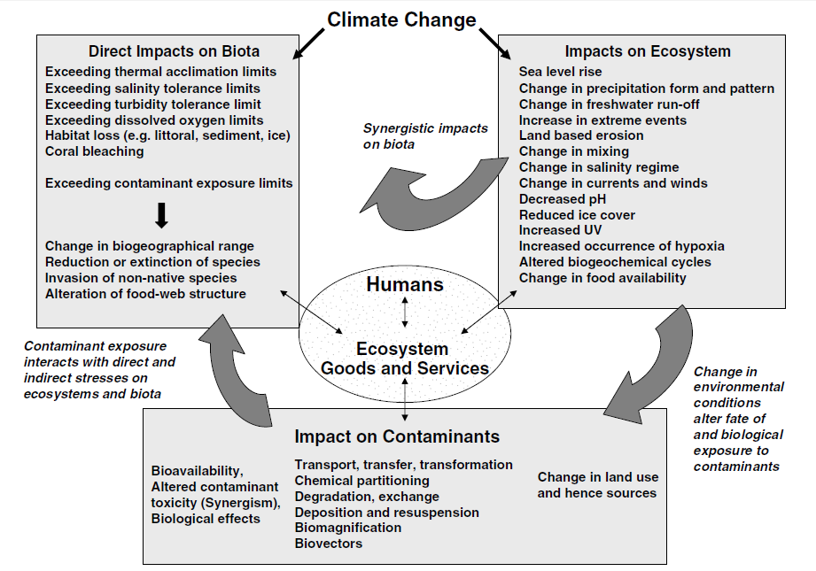

Foodborne Diseases
Foodborne diseases is one of the most significant public health issues because of the numerous cases reported and their economic costs and also because many of the causative organisms are newly identified. In the US foodborne diseases as it is evaluated they caused 76 million cases of illness with 325000 admissions and 5000 deaths every year.

Seafood
Changing weather parameters have been related with the pollution of coastal waters and shellfish-related diseases. It is widely now that the Vibrio sp., and the diseases that they cause are positively linked with weather parameters and especially temperature which prescribe their seasonality and geographic distribution [20]. In temperature estuaries V. vulnificus is rarely recovered during winter months. In more subtropical regions this pathogen is abundant throughout the year. As V. vulnificus increases under modest salinity conditions, this parameter is responsible for much of the seasonal and geographic distribution of the organism. In some areas in Canada, this pathogen reached its highest concentrations at salinities lower than 15 psu. Overall, salinity lower than 15 psu lead to increase concentrations of bacteria.
Runoff from precipitation is another determinant factor in contamination of coastal waters and shellfish harvesting areas. Some surveys have revealed increase viruses in open shellfish harvesting areas during intense and severe rainfall.

Ocean Effects
Those who harvest the sea have identified the effect of ice in arctic aquatic environments. Alterations in ice climate, has the ability to affect the marine ecosystems through a bottom-up reorganization of the food chain by changing the nutrient or light cycle. Additionally, a top-down reorganization can be occurred by changing the critical environment for higher trophic levels [21]. Changes in the organization that induce alteration of the number of trophic levels in the food chain or changes in the carbon flow such as among the pelagic and benthic organisms can have a large impact in contaminants that biomagnify like mercury and other organochlorines. It is important to mention that the ice and the marine ecosystems interact through complex processes. Moreover, arctic marine ecosystems are also changed by ocean climate changes like organization shifts including the dislocation of water masses and associated populations or temperature modification [22].

Biological effects
There is a plenty of examples of how ice climate variation can influence ecosystem structure. It is important to mention that there are some changes that there is not sufficient knowledge about all the range of changes that have taken place in arctic ecosystems. The thickness and distribution of ice can affect the amount of organic carbon produced, the strains of algae that release it and communities in the water column or sediments [23]. Through the annual cycle, ice formation reduces stratification during the winter time although it increases when the ice melts in spring time. Such physical parameters, affect the nutrient supply to the surface watersheds, the light climate and the water column stability. All these parameters regulate the primary production.
Additionally, the climate change can change the routes and destinations of migratory species. For instance, the AO⁺ conditions in 1990, the Pacific Salmon pass to the arctic rivers. Likewise, a kind of whale range widely in search of food and due to the ice edge and lead systems are critical parts of their ranges, their migration varies in ice climate.
Furthermore, the climate change may encourage the spread of insect pests globally. Hence, some governments may decide to re-introduce or increase the use of banned or restricted pesticides and more specifically those that it has been shown that are effective and of low cost.

Conclusions
In assessments that were performed in the past regarding the Arctic area, and therefore Canada, terrestrial and aquatic ecosystem uptake and health of humans have been studied separately. In general they were studied as independent elements of the contamination issue. Arctic systems are correlated making this arbitrary compartmentalization hard to produce an integrated argument of why pollutants end up where they do, and how the environment combines to put certain ecosystem components a risk far from any chemical sources. The scientific evidence indicates that polar environments are extremely sensitive to change and some of these may have direct impacts on process such as the role of snow in contaminant scavenging and the sensitivity of gas-particle portioning to temperature.
Overall, as it is obvious from this study the climate change is a determinant factor for the contaminants pathways and especially in Canada. These changes can cause public health issues since the marine chain is affected and the levels of exposure to the contaminants are increased. Hence, a minimization of these effects could be accomplished only through the control of the released of the contaminants in order to limit the climate change.

Bibliography

[1] | Tett, S.F.B., Stott, P.A., Allen, M.R., Ingram, W.J., Mitchell, J.F.B, "Causes of twentieth-century temperature change near the Earth’s surface," Nature, pp. 569-72, 1999.
[2] | Barnett, T.P., Pierce, D.W., AchutaRao, K.M., Gleckler, P.L., Santer,B.D., Gregory, J.M., Washington, W.M, "Penetration of humaninduced induced warming into the world's oceans," Science, pp. 284-7, 2005.
[3] | Jansen, J., Pronker, A.E., Wendelaar Bonga, S., Hummel, H, "Macoma balthica in Spain, a few decades back in climate history," Journal Experimental Marine Biology Ecology, pp. 161-9, 2005.
[4] | ACIA, "Arctic Climate Impact Assessment," Cambridge University Press, New York, 2005.
[5] | MacKenzie, B.R., Schiedek, D, "Daily ocean monitoring since the 1860s shows record warming of northern European seas," Global Change Biology , pp. 1335-47, 2007a.
[6] | D. Goolsby, "Mississippi Basin nitrogen flux believed to cause gulf hypoxia," Eos, Transcactions of the American Geophysical Union , pp. 321-6, 2000.
[7] | Lewis, P.N., Hewitt, C.L., Riddle, M., McMinn, A, "Marine introductions in the Southern Ocean: an unrecognized hazard to biodiversity," Marine Pollution Bulletin , pp. 213-23, 2003.
[8] | W. Steffen, "The anthropocene, global change and sleeping giants: where on Earth are we going?," Carbon Balance and Management 1. doi:10.1186/1750-0680-1-3., 2006.
[9] | Macdonald, R.W., Harner, T., Fyfe, J, " Recent climate change in the Canadian Arctic and its impact on contaminant pathways and interpretation of temporal trend data," Science of the Total Environment, vol. 342, pp. 5-86, 2005.
[10] | M. Depledge, "Interactions between heavy metals and physiological processes in estuarine invertebrates," Estuarine Ecotoxicology, pp. 89-100, 1990.
[11] | Lee, B-G., Wallace, W.G., Luoma, S.N, " Uptake and loss kinetics of Cd, Cr and Zn in the bivalves Poamocorbula amurenis and Macomabalthica: effects of size and salinity," Marine Ecology – Progress Series, vol. 175, pp. 177-89, 1998.
[12] | Ramachandran, S., Sweezey, M.J., Hodson, P.V., Boudreau, M., Courtenay,S.C., Lee, K., King, T., Dixon, J.A, "Influence of salinity and fish species on PAH uptake from dispersed crude oil," Marine Pollution Bulletin, vol. 52, pp. 1182-9, 2006.
[13] | Fries, J.S., Noble, R.T., Kelly, G.M., Hsieh, J.L, "Storm impacts on potential pathogens in estuaries," Eos, Transactions of the Americal Geophysical Union, vol. 88, pp. 93-5, 2007.
[14] | Ciutat, A., Widdows, J., Readman, J.W, "Influence of cockle Cerastoderma edule bioturbation and tidal-current cycles on resuspension of sediment and polycyclic aromatic hydrocarbons," Marine Ecology Progress Series, vol. 328, pp. 51-64, 2006.
[15] | Widdows, J., Brinsley, M, "Impact of biotic and abiotic processes on sediment dynamics and the consequences to the structure and functioning of the intertidal zone," Journal of Sea Research, vol. 48, pp. 143-56, 2002.
[16] | Ma, J., Hung, H., Blanchard, P, "How do climate fluctuations affect persistent organic pollutants distribution in North America? Evidence from a decade of air monitoring," Environmental Science Technology, pp. 2538-43, 2004.
[17] | Welch, H.E., Muir, D.C.G., Billeck, B.N., Lockhart, W.L., Brunskill,G.J., Kling, H.J., Olson, M.P., Lemoine, R.M, "Brown snow: long-range transport event in the Canadian Arctic," Environmenal Science and Technology, vol. 25, pp. 280-6, 1991.
[18] | H. Dahlgaard, "Transfer of European coastal pollutinon to the Arctic: radioactive tracers," Marine Pollution Bulletin, vol. 31, pp. 3-7, 1995.
[19] | Macdonald, R.W., Mackay, D., Hickie, B, "Contaminant amplification in the environment: revealing the fundamental mechanisms," Environmental Science and Technology, vol. 36, pp. 457A-462A, 2002.
[20] | Motes ML, DePaola A, Cook DW, Veazey JE, Hunsucker JC, Garthright WE, Blodgett RJ, Chirtel SJ, "Influence of water temperature and salinity on Vibrio vulnificus in Northern Gulf and Atlantic Coast Oysters (Crassostrea virginica)," Appl Environ Microbiol, vol. 64, pp. 1459-65, 1998.
[21] | P. TR, "The removal of marine predators by fisheries and the impact of trophic structure," Mar Pollut Bull, vol. 25, pp. 51-3, 1992.
[22] | Feder HM, Norton DW, Geller JB, "A review of apparent 20th and macroalgae in Arctic Alaska, and of historical and paleontological evidence used to relate mollusc distributions to climate change," Arctic, vol. 56, pp. 391-407, 2003.
[23] | Niebauer NJ, Alexander V, "Oceanographic frontal structure and biological production at an ice edge," Cont Shef Res, vol. 4, pp. 367-88, 1985.
[24] | Bloomfield, J.P., Williams, R.J., Gooddy, D.C., Cape, J.N., Guha, P, "Impacts of climate change on the fate and behaviour of pesticides in surface and groundwater-a UK perspective," Science of the Todal Environment, vol. 369, pp. 163-77, 2006.
[25] | Eastaugh J, Shepherd S, "Infectious and toxic syndromes from fish and shellfish consumption," Arch Intern Med, vol. 149, pp. 1735-40, 1989.

